DOCUMENTATION

ASSIGNMENT 3

STUDENT NAME: Veres Noémi
GROUP: 30423

CONTENTS

1. Objective 3
2. Problem analysis, modeling, scenarios, use cases 3
3. Design 4
4. Implementation 6
5. Results 7
6. Conclusion 7
7. Bibliography 7

Objective
The main objective of Assignment 3 is to design and implement an Orders Management system for processing client orders for a warehouse. The application should have a dedicated graphical interface through which new clients and new products can be inserted and those clients can make orders consisting of different products.
The sub-objectives are the following:
- Analyze the problem and identify requirements
- Design the orders management system
- Implement the orders management system
- Test the orders management system

For this assignment, we had several methods to implement. The problem analysis will be detailed in the next chapter: 2. Problem analysis, modeling, scenarios, use cases. The design of the orders management system had to be made by a specific architectural pattern. I used Conceptual Architecture, which is explained in the 3. chapter. The implementation is detailed in the 4. chapter, where all the classes are presented and their main methods. Whenever writing a program, testing is an essential part of it, however, we must remember that “The absence of evidence is not necessarily evidence of absence”. Even though all the test cases are running correctly, this does not mean that our program is free of errors as we cannot cover all the special cases. We can only minimize the chance of running into problems. Further information about testing the orders management system can be found in the 5. chapter.

Problem analysis, modeling, scenarios, use cases
The functional requirements of this problem are:
- The application should allow an employee to add a new client
- The application should allow an employee to delete an existing client
- The application should allow an employee to update an existing client
- The application should allow an employee to view all the clients
- The application should allow an employee to add a new product
- The application should allow an employee to delete an existing product
- The application should allow an employee to update an existing product
- The application should allow an employee to view all the products
- The application should allow an employee to make a new order
- The application should allow an employee to view all the orders

Non-Functional requirements might include:
- The Orders management system should be intuitive and easy to use by the user
- The Orders management system should be reliable, the result should be precise, for the user to trust our application
- The Orders management system should deal with incorrect user inputs and display messages that can help the user find the issue (for example: Wrong input data! You should insert integers. or Wrong input data! You cannot insert negative numbers for the price.)

Now the use cases will be presented.
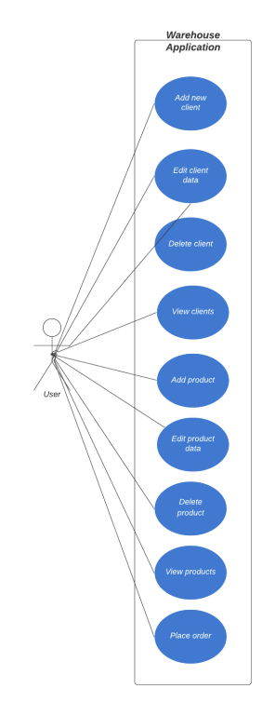

Use Case: add new client
Primary Actor: user
Main Success Scenario:
1. The user clicks on the “Client” button
2. The user enters the data of the new client in the row placed under the “Add client” button
3. The user presses the “Add client” button
4. The new client is added to the database.
Alternative Sequence: Invalid values for the new client
The user inserts invalid values for the new client
The application displays an error message and requests the user to insert valid values
The scenario returns to step 1

Use Case: update an existing client
Primary Actor: user
Main Success Scenario:
1. The user clicks on the “Client” button
2. The user enters the new data in the row placed under the “Edit client” button
3. The user presses the “Edit client” button
4. The client will be updated in the database
Alternative Sequence: Invalid values for the updated client
The user inserts invalid values for the editable client
The application displays an error message and requests the user to insert valid values
The scenario returns to step 1

Use Case: delete an existing client
Primary Actor: user
Main Success Scenario:
1. The user clicks on the “Client” button
2. The user enters the id of a client in the row placed under the “Delete client” button
3. The user presses the “Delete client” button
4. The client will be deleted from the database
Alternative Sequence: Invalid id
The user inserts an invalid id, i.e., the client with the given id does not exist
The application displays an error message and requests the user to insert a valid id
The scenario returns to step 1

Similar use cases can be defined for the products, by replacing above the word “client” with “product”.

Use Case: place an order
Primary Actor: user
Main Success Scenario:
1. The user clicks on the “Order” button
2. The user selects a client from the clients table.
3. The user selects a product from the products table.
4. The user specifies the quantity of the product.
5. The user presses the “ORDER” button
6. The “Order was placed” message is displayed.
7. The databases are updated accordingly.
8. A bill is generated.
Alternative Sequence: There are not enough products
The user wants to place an order for a product exceeding the available quantity.
The application displays an error message and informs the user that there are not enough products available.
The scenario returns to step 4.

Design
For this assignment, I have 6 packages inside main.java: bll, dataAccess, model, presentation, start, and utils. I have used a specific architectural pattern, the so-called Conceptual Architecture pattern. In the sub-packages, I grouped the classes which are correlated. For this, a model package is needed, which contains the classes mapped to the database table. The Presentation Layer contains the classes related to the graphical user interface, like View and Controller. It communicates with the business logic and model. The Business Layer classes are the ones who encapsulate the application logic and the Data Access Layer contains the classes with the queries (dao) and database connection (connection). The start package contains only one class, which has the main method for starting the application. Finally, a utils package was added, which contains the TableFactory class needed for generating the header of a table by extracting through reflection the object properties and then populating the table with the values of the elements from the given list.
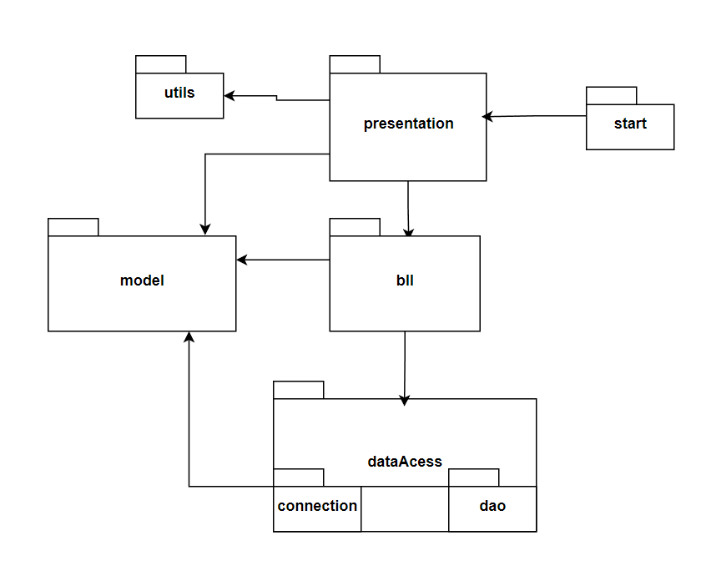
The following UML diagram shows us the dependencies between some of the classes and the main methods of each class:

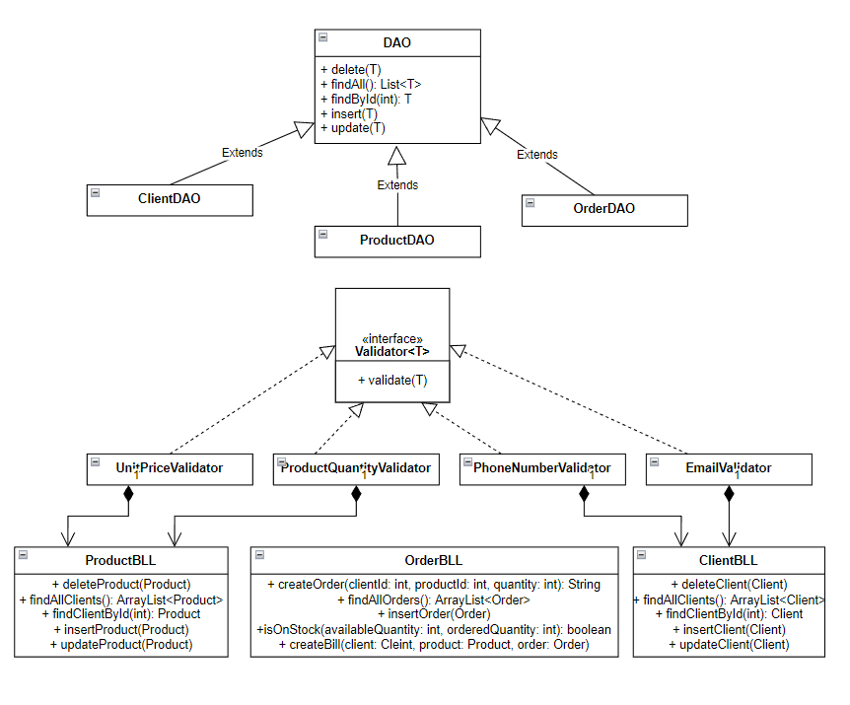

Implementation
Let us take each class separately and describe their main fields and methods.
The Model package contains 3 classes: Client, Order and Product. Each one has its own fields, which are actually the column names from the databases. For example, a product has an id, a name, a unit price and a quantity. The Client class represents the client from a warehouse and the Product class represents the product from the warehouse respectively. The Order class represents an order placed by a client for a specific product. In each of these classes, we have 2 constructors: one with parameters and one without. They also contain getters and setters for the fields and an overridden toString() method.
The View class is using Java Swing, to create a user-friendly graphical interface. We have many private fields here, of type JPanel, JLabel, JTextField, and JButton – for activating some operations. The constructor receives a String, which will be the name of our application as all frames must have a name. One other method is prepareGui() which will prepare the main window of our application. We also have three other windows: for the client, product and the orders. In these classes I also used JTables which required also some getters to access them. I placed labels in the frames, to inform the user what they have to do.
In the Controller class, we make the connections between the View and Model. Apart from the constructor, we have an actionPerformed(ActionEvent e) method, which gets some commands as a String. Using if statements, we decide what to do when certain buttons are pressed.
In the presentation package, I have two other classes: ReadingARow and RowListener which help us select a certain client and a certain product from the existing tables. After that, an order can be made.
With the ConnectionFactory class we make the connection with the database. Only one ConnectionFactory instance exists as we are using the Singleton Pattern.
The data access object (DAO) is a pattern that provides a generic class to some type of database. It has some methods like findAll(), findById(), insert(), update(), or delete(). For each of these methods we had to write a String query, an expression from SQL. For example, when we want to delete with a certain id, we write the following syntax:
String query = "DELETE FROM `" + type.getSimpleName() + "` WHERE id = ?";
When we are searching for the id column, we write the following code:
for(Field field : type.getDeclaredFields()){
if(field.getName().equals("id")){
primaryKey = field;
}
}
Then, we will have to set the primary key to accessible:
primaryKey.setAccessible(true);
The ClientBLL class is responsible for the business logic involving clients, just as OrderBLL is responsible for the operations with orders and ProductBLL is for products. For creating a new order, a client and a product has to be selected and then the quantity must be specified:
createOrder(int clientId, int productId, int quantity)
For checking whether there are enough products on stock, I implemented the following method:
public boolean isOnStock(int availableQuantity, int orderedQuantity) {
return availableQuantity >= orderedQuantity;
}
which returns true only if we have enough available quantity.
The Validator interface contains one abstract method: validate, which will validate the user input. The EmailValidator, PhoneNumberValidator, ProductQuantityValidator and UnitPriceValidator classes implement this method, the first two being related to the client and the other two are related to a product.
The TableFactory class uses reflection techniques for the following methods: retrieveColumns(E object) and retrieveData(ArrayList<E> objects, int length). Finally the createTable() method creates a table with the columns and data obtained with the previous methods.

Results
Whenever a new client or product is added, we can see the changes in the interface. This applies for the other
operations too. More complex was the requirement of creating a new order.
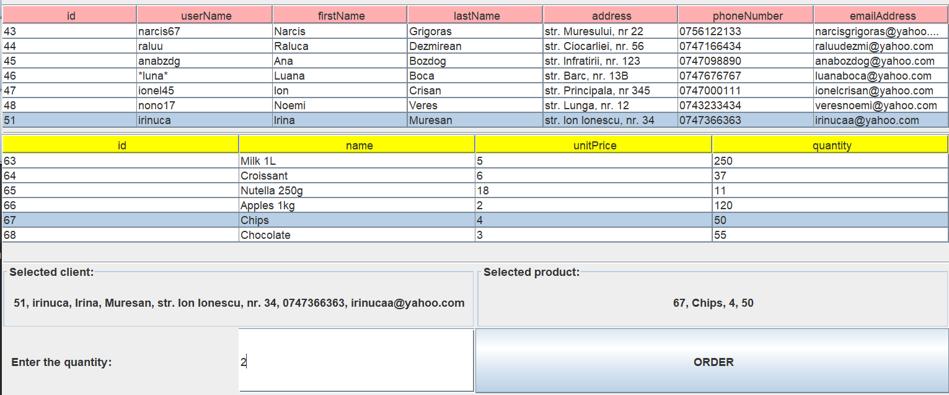
A client and a product should be selected first and then a quantity should be specified. If all goes right, when the user presses the “ORDER” button, he/she gets the following message:
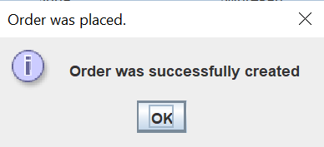
A bill will also be generated as a txt file:
Client: Irina Muresan
Product name: Chips
Quantity: 2
Unit price: 4
Total: 8

Conclusion
There were many concepts and also practical things that I have learned from this assignment. I learned how to divide the whole system into smaller parts, using a specific architectural pattern, the Conceptual Architecture in this case. The main parts of this architecture are the graphical user interface (GUI) – the presentation layer, business logic, data models and data access which is connects to the mySQL database.
For this assignment, I had to learn to use reflection techniques to retrieve the columns and data from a table. Using Javadoc comments was another essential part, I learned how and where to use them.
The generic AbstractDAO class contained the main methods needed for each Client, Product or Order in particular.
All in all, this assignment helped me divide a complex program into small subproblems, efficiently solve them and then recombine them to obtain the final application with all of its functionalities.
The application can be further developed, for example, we could run multiple simulations in parallel. It would be also interesting to combine the selection policies or just change them while the application is running. The user interface could be much more friendly by using different colors. Not all of user input cases are validated, so other error messages should also be displayed. In order to be more clear and readable, the controller class could be divided into other classes, the main controller, from where we could select whether we want to perform an operation on a client product and order. The other 3 classes could be ClientController, which would react to the buttons from the ClientWindow, the ProductController for the ProductWindow and the OrderController for the OrderWindow.

Bibliography

I mainly used the source code provided on https://gitlab.com/utcn_dsrl/pt-layered-architecture for this assignment. The presentation provided on the course website was also useful, containing some suggestions about the design and theoretical background of Java Database Connectivity: FUNDAMENTAL PROGRAMMING TECHNIQUES (dsrl.eu). For selecting a certain row in the clients or products table, I consulted the following website: how to get the values from selected row of JTable (Swing / AWT / SWT forum at Coderanch).

